DATE: 20.09.2019
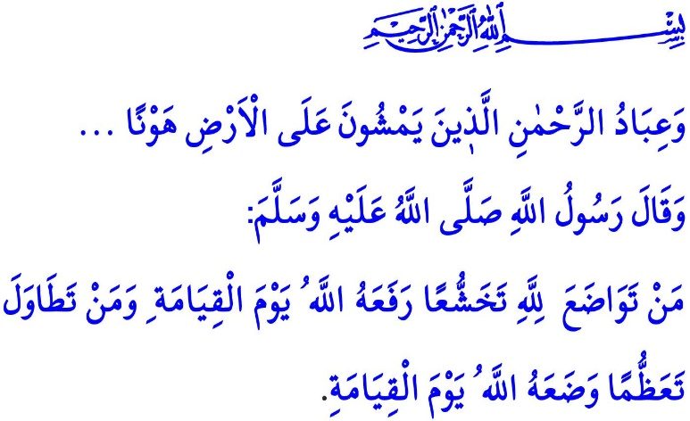
HUMILITY EXALTS US
Honorable Muslims!
In the verse I have just recited the Almighty Allah (swt) states, “The servants of Allah the Most Gracious are those who walk on the earth in humility...”
In the hadith I have just read the Prophet Muhammad (saw) says, “Allah shall exalt humble people on the Day of Judgment for showing humility for His sake. He shall degrade arrogant people on the Day of Judgment for showing disdainful pride.”
Dear Believers!
Doing righteous deeds and having good morals are the greatest manifestation of perfect faith in one's life. This is because good morals are the most valuable asset to illuminate the life in this world and turn the eternal life in the Hereafter into heaven. We as Muslims believe that a life cannot lead to heaven without good morals. On top of these good morals comes humility that will exalt us in the presence of Allah.
Humility is the quality or state of being unpretentious and modest. It means staying away from self-praise and boastfulness. It means adopting a life free of pride and arrogance. It means showing respect, compassion, and mercy to all living beings and treating them gently.
Dear Muslims!
The Prophet Muhammad (saw) is the example of humility for us as Muslims. He led a simple and modest life. He would value and respect people for the sake of being human. He would know that being humble was one of the characteristics of those people to enter to heaven. He would warn us that looking down upon our Muslim brothers and sisters would be enough as an evil act. Referring, in one occasion, to the fact that humility was a personal trait that would exalt people in the presence of Allah (swt), he said, “…Allah increases his dignity who is tolerant, and exalts him who is humble.”
Dear Believers!
Humble Muslims whose role model is the Prophet Muhammad (saw) know that the true owner of all the blessings is the Almighty Allah (swt). They also know that all blessings in their possession are tools for them to be tested. They spend all their capabilities in the cause of attaining Allah's (swt) consent and approval. They never place themselves in a superior position compared to other people, regardless of their level of authority or status. They believe that the superiority of people in the presence of Allah (swt) is measured only by their piety.
Dear Muslims!
Islam aims to equip Muslim souls with humility on the one hand, and on the other hand, it warns them to be far from being arrogant to the extent possible. This is because, as expressed in the Prophet Muhammad's (saw) words, “Arrogance means rejecting the truth and despising people.”
Arrogant people think the world turns around them. They belittle other people and turn their back on them. Muslims, however, should never depreciate anybody for any reason whatsoever. In this regard, the Prophet Muhammad (saw) warns us as follows, “Allah has revealed to me that you should be humble and that you should not wrong one another.”
Dear Believers!
Muslims, just like in all their affairs, should not go to extremes in humility. This is because while they are obliged to lead a humble life, they are also responsible to protect their own honor and dignity, as well as those of their Muslim brothers and sisters. They maintain their dignified and temperate stance against people who depreciate Muslims. They do everything in their power to protect Muslims' honor and dignity. They take to their hearts the following commandment of the Almighty Allah (swt), “Muhammed is the Messenger of Allah. Those who are with him are strong against unbelievers, but compassionate amongst each other..."
Honorable Believers!
Let us adopt humility in all domains of our lives. Let us not hurt anybody. Let us not sadden each other by falling for the temporary desires of this mortal world. Let us avoid arrogance, haughtiness, and hypocrisy that will turn our world into a prison and our eternal life into hell. Let us not belittle people or make a face at them. Let us not walk on earth arrogantly. Let us not forget that the Almighty Allah (swt) does not like those people who are arrogant and self-praise themselves.

Furqan, 25/63.
(Ibn Hanbal, II, 76)
Muslim, Zuhd, 33.
(Bukhari, Adab, 61)
(Muslim, Birr, 32)
Muslim, Birr, 69.
Muslim, Iman, 147.
Muslim, Jannah, 64.
Fath, 48/29. General Directorate of Religious Services

